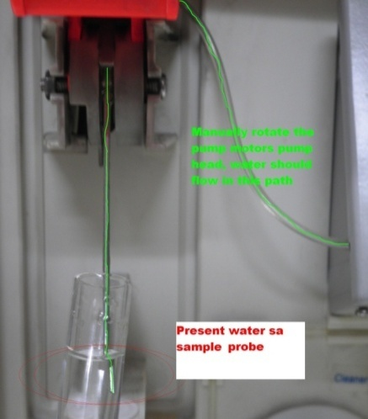Step: 3 (Blockage check – left side)

* Return all the tubes na naremove from step 2
* Present water sa sample probe
* Manually rotate the pump motor’s pump head
* Observe kung may water na nasipsip

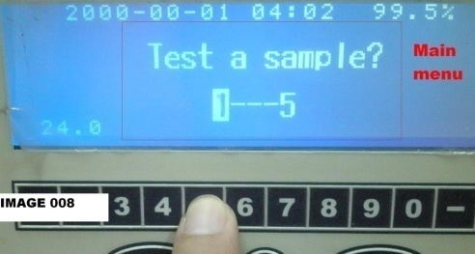Kung wala:

* Gamitin an acupuncture needle sa pageliminate ng blockage sa metallic sample probe.
* 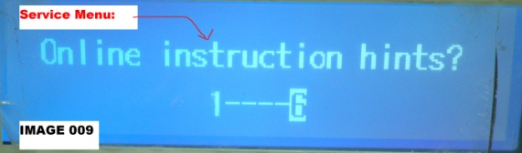Disable ang alarm para kapag eopen ng electrodes chamber cover, hindi sya mag iingay, para magawa ito follow the following instructions:

1. 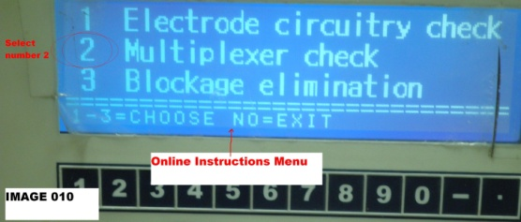From the Main Menu, Go to “services” which is in number 5, to select it, you can click the “No” button for 5 times or just simply press the button number “5” (image 008)
2. Select the “Online instruction hints” which is in number 6
3. 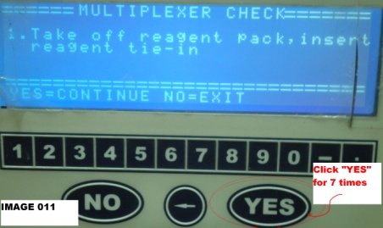Press number “2” button which is the “Multiplexer check”
4. Press “YES” for 7 times until it reach the last instruction.

* Remove the electrodes from the electrodes chamber, to execute this, perform the following procedure:

1. 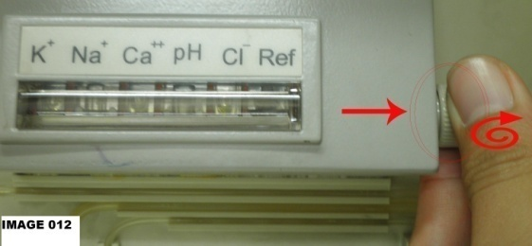Open ang cover ng electrodes chamber
2. ePull at rotate an knob na nasa right side para matanggal ang mga electrodes (Image 012)
3. Remove the electrodes (push the electrode UP and then PULL it.

* 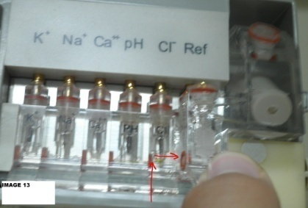Unclog the sample entrance to electrodes using acupuncture needle(Image 014)
* Unclog the sample detector using acupuncture needle (image 015)

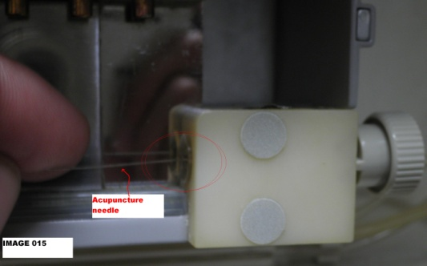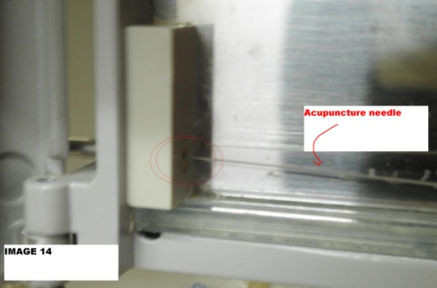

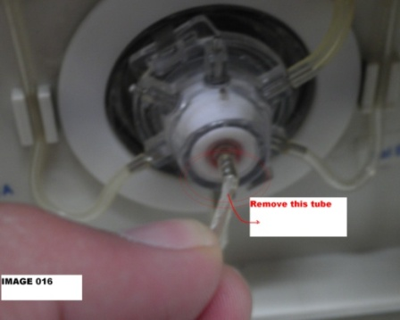

Kung Meron: Proceed to the next step

Step 4: (Blockage check – Lower Part)

* Remove the tube (Image 016)
* Immerse it in the water (Image 07)
* 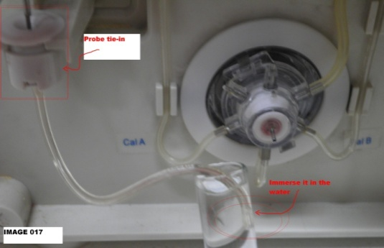Rotate the pump motors pump head counter clockwise and observe it if the water is flowing inside the tube.

Kung Wala:

* Replace the probe tie-in (may spare to, nasa service kit)

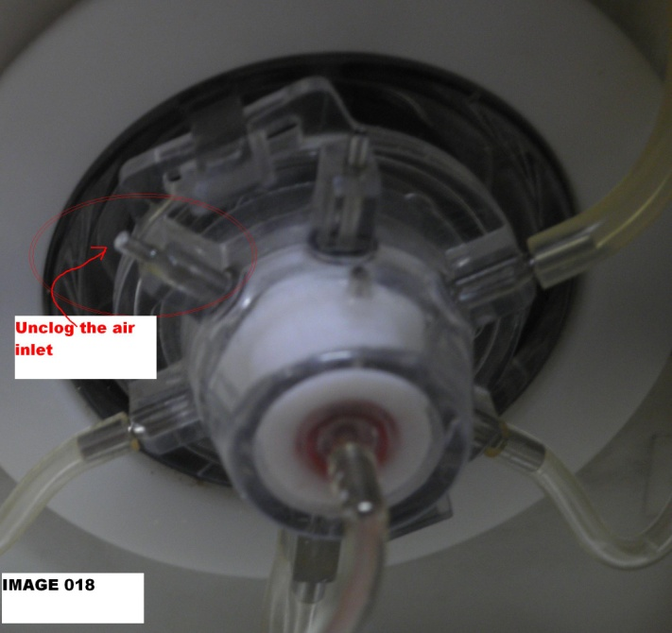

Kung Meron: Proceed to the next step

Step 5: (Blockage check – Multiplexer) entrance

* Unclog the air inlet (Image 018)